**Taiwan-Paraguay Polytechnic University**

**Industrial Management Department Internship Application Procedure**

**during 8th Semester**

1. **Qualification (Student)**

（1）The student who is in the 8th semester in Taiwan-Paraguay Polytechnic University is eligible for having the internship. The application needs to be submitted during 5-7th semester with a student identity in NTUST. The number will be limited to six applicants in order of submissions.

（2）Applicant should find advisor also submit the Internship Application form (as appendix 1)with a letter of consent from the internship institution (as appendix 2)as well the official transcript in 5th and 6th semester two months before beginning the internship(the deadline will be around the end of March) to IM office.

1. **Qualification (Institution)：**

Student should search the internship institution and vacancy which is related to IM concentrations on his/her own. The department will negotiate the contract signing. The qualification of institution shall meet one of the 3 requirements as bellows：

（1）Listed Company.

（2）Non-listed Company shall be evaluated as well recommended by the advisor.

（3）Micro-enterprises, the student who hold shares and is one of the owners, is going to be dealt with special case of evaluation.

The institution is required to offer “The Based Information form of Internship Institution” (as appendix 3) if it has not signed the contract with IM before. The contract negotiation will be initiated once the conference admits the qualification (both applicants and institution).

1. **Contract signing：**

The office will negotiate the contract either in Mandarin or English「台科大校外實習合約書_非僱傭關係版TEEP」(as appendix 4,5) with the institution.

1. **Internship advisor：**

Each student will under the supervision of their advisor.

During the internship, advisor is required to provide interns with professional guidance, coordination, and communication services through phone or practical visitation irregularly.

1. **Internship certificate：**

Once the internship finished, the Institution should issue “Internship Certificate” for the interns

on request. (as appendix 6).

1. **Internship certificate：**

Students will no longer have student identity in their 8th semester. OIA will be in charge of applying for extension of visa (6 months) based on the signed TEEP contract for interns. There is no requirement to apply for working permit since it does not have Employers-employee Relations.

**The Procedure of Applying the Internship in IM department Taiwan-Paraguay Polytechnic University during 8th Semester.**

**The Application**

Required Documents:

1. Taiwan Tech Off-campus Work as Interns Application form (appendix 1)

2. A letter of consent from the internship institution (appendix 2)

3.Officail transcript in 5th and 6th semester

**should be submitted in advance**

The internship application canceled

Failed

Failed

The internship application canceled

Passed

Passed

**Appendix 1**

**國立臺灣科技大學專業成長實習申請表**

**Taiwan Tech Off-campus Work as Interns Application form**

|  |  |  |  |
| --- | --- | --- | --- |
| 系所  Department |  | 學號/居留證號碼  Student ID /ARC No. |  |
| 學生姓名  Full Name |  | 學生連絡電話  Contact phone No. |  |
| 學生email |  | | | |
| 實習期間  Period of Internship | 1. 年 月 日 至 年 月 日  2. 年 月 日 至 年 月 日  The period shall be valid from YYYY/MM/DD to YYYY/MM/DD | | | |
| 實習機構Internship Institution |  | 負責人  Institution  Representative |  |
| 實習機構  連絡人  Institution Contact |  | 實習機構  聯絡電話  Institution Phone No. |  |
| 實習地點  Venue/Working place |  | | | |
| 實習內容  Internship content | 學生簽名：  Signature of Student:  ※表格如不敷使用，請自行增列。  ※If the space provided is insufficient, you can attach a separate page for additional  information. | | | |
| 申請結果  Application result | □同意實習Approval　　　　□不同意實習Disapproval | | | |
| 實習輔導教師或導師簽章 | Signature of Advisor | | | |
| 單位主管簽章 | Signature of the Department chair | | | |

**Appendix 2**

**廠商實習電子書面同意函(範例)**

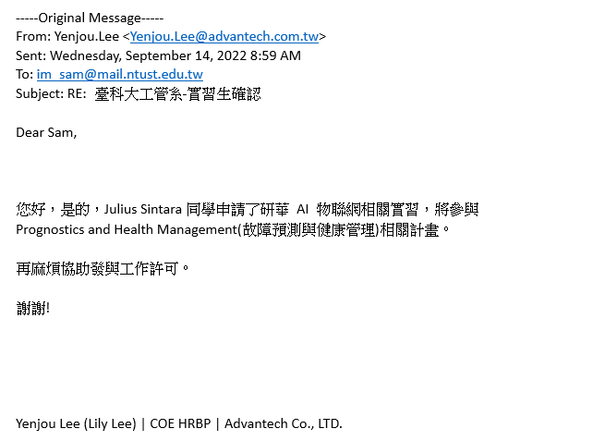

**廠商來信**

**(同學姓名)**

**系所實習承辦人**

**A Letter of Consent (Example)**

**Subject：The internship confirmation**

I am here to present the (Name of institution) has agreed to hire (Name of applicant) as intern from xxx to xxx (The period of internship).

The position is about to xxxx, the working time will be xx hours a week approximately, total for xx hours.

**The signature by HR or Representative**

**國立臺灣科技大學**

**Appendix 3**

**實習機構基本資料表**

**The Based Information form of Internship Institution**

本表若不敷使用請自行延伸

|  |  |  |  |  |  |
| --- | --- | --- | --- | --- | --- |
| 公司名稱 |  | | | | |
| 負責人 |  | | 統一編號 |  | |
| 聯絡人 |  | | 職稱 |  | |
| 聯絡電話 |  | | 傳真 |  | |
| 公司地址 |  | | | | |
| E-mail |  | | | | |
| 公司簡介 |  | | | | |
| 年營業額 |  | | 員工人數 |  | |
| 休假/補休方式 |  | | | | |
| 其他說明 |  | | | | |
| 暑期實習期間： 年 月 日至 年 月 日止 | | | | | |
| **實習系別** | **工作項目及條件**  **(請詳填工作內容)** | **名額** | **工資/獎助學金**  **(請詳填薪資)** | **需求條件/備註**  **(請詳填實習地點及需求條件)** | **總實習時數/人** |
| 工業管理系 |  |  |  |  |  |
| 學期實習期間： 年 月 日至 年 月 日止 | | | | | |
| **實習系別** | **工作項目及條件**  **(請詳填工作內容)** | **名額** | **工資/獎助學金**  **(請詳填薪資)** | **需求條件/備註**  **(請詳填實習地點及需求條件)** | **總實習時數/人** |
|  |  |  |  |  |  |

以下問題請填寫

1. 貴公司履歷收件截止日及收件人E-mail?

(應徵者除繳交履歷表，尚需繳交何文件?公司是否有制式表格?)

1. 面試通知日? (請提供期間，以利告知學生)
2. 錄取公告日?
3. 是否有限制大學部或研究所及其年級? (例如大三或大四?)
4. 貴公司是否有上市/上櫃?如有請提供代號或簡稱。
5. 貴公司是否有相關ISO認證或政府得獎紀錄等?

**Appendix 4**







**Appendix 5**





**Internship Certificate in Industrial Management Department**

**Appendix 6**

**Taiwan-Paraguay Polytechnic University**

|  |  |  |  |
| --- | --- | --- | --- |
| Full name |  | Date of birth |  |
| ARC NO. |  | | |
| Dept. |  | | |
| Position |  | | |
| Period of Internship | YYY MM DD to YYY MM DD  ( hours/one month)  YYY MM DD to YYY MM DD  ( hours/one month)  Total for hours | | |
| Note: |  | | |
| Name of Internship Institution:  Address of Internship Institution:  Institution Representative:  **This certificate will not be admitted without the formal stamp from the Institution.**  中華民國 年(YYYY) 月(MM) 日(DD) | | | |